LAKE ERIE CHURCH OF GOD
3050 Antioch Road, Perry, Oh 44081
November, 2016

IN THIS ISSUE
- Reflections
- A View from the Pew
- Broken Wings Ministry, Inc.
- Upcoming Events
- Praise on the Lake Children’s Ministry News
- Thirst Ministry News

Pastoral Staff

Bishop Phil Pearson – Senior Pastor
Dustin Vorse - Youth Pastor
Elder Don Tyree – Pastoral Care
Jerome Barclay – Minister of Music
Becki Perkins – Secretary
Alexis Gerics & Becki Perkins
Finance Directors

Office Hours
Monday – Thursday 9:00 – 2:00
Come Worship with us:
9:00A.M. – Connection Class
10:00A.M. – Morning Worship
Monday Breaking Free Book Study
6:30 P.M.
Meet us at The Well on Wednesdays
6:30A.M. – Bible Study
7:30 P.M. – Choir Practice
Visit us on Facebook at:
http://facebook.com/lakeeriechurch
LEC Website:
http://www.lakeeriechurch.com
Church Office:
(440) 259-2310
Bishop Phil Pearson, Pastor

REFLECTIONS
K’s Korner
Let’s be Thankful

T Give God your Time with thankfulness.
H Let your heart be full of God’s grace.
A Ask the Lord to clean your heart.
N Never lie and complain be thankful in all things.
K Be Kind one to another.
F Without Faith it is impossible to please God.
U Stay Under the shadow of the almighty.
L Let’s Lift up our hearts and be thankful.

When you have purposed in your heart to be Thankful, things don’t seem so hard. You begin to think on those things that are lovely, just, pure and of a good report. There are many unaware blessings to flow your way. Many times we look around and wonder how I can be thankful in this or that situation. Look a little closer and you can find something to be thankful for. Start with little things. You may feel foolish, but remember it’s not about your feelings. It’s about being obedient to God and his word.

By Kinja Walton

“View From The Pew”

Join us on
Wednesday Nights for our God’s Not Dead 2 Group Study
At 6:30 P.M.

LEC family praying for you!

Sandra Breedlove
Alexis Gerics
Tom Saunders
Ina Coates
Dee Bayless
Betty Raimey
Marion Rice
J.J.
Drug Addiction

Join us for the Breaking Free Book Club
Mondays @ 6:30 P.M. as we study
“The Deborah Anointing”
By Michelle McClain-Walters.
Join us for our 5:00 A.M. prayer
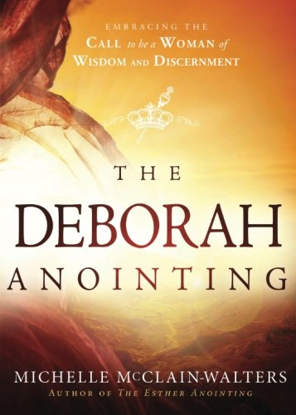

Join us every Sunday Morning for
Pre-Service worship at the altar
9:45 A.M. Let’s call down God’s
Anointing as one body.

Not a Silent Night: Book Study
Thursdays at 9:00 A.M.
The cost of the book is $12.00
Please sign up at the information table.
For more information see Erica Shaw

How to Cultivate New Relationships

Romans 14: 22-23
Cultivate your own relationship with God, but don’t impose it on others. You’re fortunate if your behavior and your belief are coherent. But if you’re not sure, if you notice that you are acting in ways inconsistent with what you believe—some days trying to impose your opinions on others, other days just trying to please them—then you know that you’re out of line. If the way you live isn’t consistent with what you believe, then it’s wrong.

Cultivating personal relationships requires a willingness to invest of your time, energy, and self without guarantee of a beneficial return. Still, relationships can be one of the most rewarding experiences of life; it is up to you to decide if the effort is worth the risk.

- Be willing to express your desire to get to know someone. If you have someone in mind, you may have already begun to make inroads in this direction; you just need to decide what works for you.
- Look for a person or people who have similar interests and values as yourself. Age is not an automatic requirement, but great disparities in age may equate to fundamental differences in life views.
- Consider availability. If you or the person you are seeking to form a relationship work different shifts, live a significant distance apart, or are involved in complicated family situations that demand a substantial amount of time, you may find these to be obstacles to working toward a relationship.
- Practice listening to the person you are interested in developing a relationship with. This will give you insight on their history, philosophy, and expectations from a relationship.
- Ask the person questions. People are more likely to respond if they feel you are interested in them, than just discussing the weather, sports, business, and the like. Be aware that they may not want to share a lot of detail at the beginning, but building trust is fundamental to developing a relationship to begin with.
- Remember details. Remembering birthdays, names and ages of relatives, and other significant information will show the person you really are interested, not just enjoying small talk.
- Be willing to let your own guard down. This doesn’t mean telling all your deepest, darkest secrets, just be willing to talk about yourself. Many people find this a difficult thing to do.
- Forgiveness is also important in a relationship that has value to you. To keep a personal relationship, try to listen before criticizing. Especially when you feel as though there is something to be angry about, it’s important to hold your tongue and try to understand the other person. This way, you can grow in a relationship.
- Remember that the other person is not there to make you happy. Your happiness is your responsibility so minimize blaming. This way, you can enjoy the other person’s company without feeling dependent on them.
- When beginning to build a relationship, take care to recognize names, dates, and events that are mentioned while talking. This tends to emphasize the fact you care about them.

Many times, people expect different things in a developing relationship, and failing to meet those expectations can cause regrets and pain down the road. Just be yourself, be honest, open, and transparent, and before you know it you will have cultivated a new friendship.

Submitted by: Broken Wings Ministry, Inc.
Elder Melvin & Jennifer Rankins

Join us on
Saturday Dec. 3rd for our 10th annual
“Repeat the Sounding Joy” Christmas Concert
At 6:00 P.M.
Join us for Grief in the Holidays
On Nov.10th from
4:00 P.M. - 5:00 P.M.
Afterwards stay for a Potluck Dinner

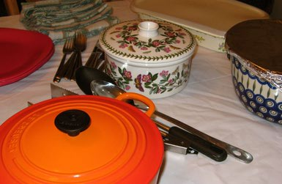

Remembrance Service November 19th
At 4:00 P.M.

Consider sponsoring a teen for our Youth Retreat 2017
For as little as $10.00
A week you can mark your envelope and drop it in the offering on Sundays

Praise on the Lake Kids Ministries
Christmas Program Practice has begun!!
Every Sunday till 3:00P.M.
See Brother Tom Burnett
For more information

Thirst

Will have its first
“Love is Red Conference”
March 17th & 18th 2017
In Canton, Ohio
A $30.00 deposit will be needed by Nov.20th
Please see Pastor Dustin

